Article type - Research Article

MAPPING THE INTELLECTUAL STRUCTURE OF INTANGIBLE CULTURAL HERITAGE RESEARCH IN GASTRONOMY: A BIBLIOMETRIC ANALYSIS

How to cite:
Received …………….; Revised ………; Accepted ……….; Available online …………………
© 2026 The Author(s); Licensed under CC BY-NC 4.0
Abstract
This study aims to evaluate the development and intellectual structure of the literature on intangible cultural heritage in the field of gastronomy over time through bibliometric analysis. The research dataset was obtained from the Web of Science Core Collection database and includes a total of 3,155 articles and review studies indexed in SCI, SSCI, ESCI, and AHCI between 2006 and 2025. The obtained data were analyzed using VOSviewer software to reveal publication trends, prominent countries, influential authors and journals, citation relationships, collaboration networks, and thematic transformation in the research area. The analysis results show a significant increase in the number of publications, especially since the mid-2010s, and that intangible cultural heritage research in the context of gastronomy is becoming an increasingly visible and institutionalized academic field. Furthermore, the findings reveal that the field is not limited to gastronomy alone; it exhibits an interdisciplinary structure that develops in interaction with different subfields of cultural studies, sustainability, tourism, anthropology, and social sciences. When evaluated on a country basis, Spain and Italy, in particular, are seen to be among the leading countries in the field in terms of both publication productivity and citations received. However, the increase in academic contributions from developing countries indicates that the research field has a wider geographical spread. Keyword association and thematic mapping results show that the research focus has changed over time. While conservation and preservation themes were prominent in early studies, current research shows that topics such as sustainability, local development, food identity, cultural tourism, community participation, and socio-cultural transformation have gained more importance. In conclusion, this study evaluates the development process of intangible cultural heritage research in the field of gastronomy from a holistic perspective and provides a guiding framework for future interdisciplinary studies.
Keywords: gastronomy, intangible cultural heritage, bibliometric analysis, food culture, culinary heritage.
JEL Classification: Z10, Z32, Q01

1. Introduction
Globalization has profoundly transformed not only economic and political systems but also the production, circulation, and representation of culture. Intensified mobility, rapid advances in communication technologies, and the widespread diffusion of information have facilitated unprecedented interactions among societies, allowing cultural practices to transcend geographical boundaries and become increasingly interconnected. Appadurai (1996) conceptualizes this transformation through the notion of global cultural “flows,” arguing that ideas, images, people, technologies, and consumption practices circulate across national borders, continuously reshaping local cultural landscapes. Similarly, Robertson (1995) maintains that globalization should not be understood solely as a process of cultural convergence but rather as a reciprocal interaction between global and local dynamics that generates diverse forms of cultural adaptation. While Ritzer (2011) emphasizes that globalization promotes the standardization of cultural practices through principles of efficiency, calculability, predictability, and control, Hannerz (1996) and Featherstone (1995) argue that it simultaneously encourages cultural diversity and hybridization through continuous intercultural exchange. Rather than producing a single cultural outcome, globalization generates both homogenizing and pluralizing dynamics, reshaping how cultural identities, traditions, and everyday practices are created, negotiated, and reproduced. More recently, digital technologies associated with globalization have expanded opportunities for documenting, preserving, and disseminating cultural heritage while simultaneously creating new challenges related to authenticity, sustainable safeguarding, and digital heritage governance (Buragohain et al., 2024; He & Wen, 2024).
Within this global transformation, culture has increasingly been recognized not merely as a symbolic system but also as a strategic resource that generates economic, social, and political value. Harvey (2001) argues that cultural heritage has become an integral component of capital accumulation and spatial restructuring under late capitalism, whereas Throsby (2010) conceptualizes culture as a form of capital capable of generating both economic benefits and cultural meaning. Complementing these perspectives, Bourdieu’s (1984, 1986) concepts of cultural capital and habitus explain how cultural practices contribute to the reproduction of identities, social values, and symbolic power relations across generations. Consequently, culture should be understood as a multidimensional phenomenon through which meanings, identities, economic values, and social relationships are continuously negotiated and reproduced. Contemporary scholarship further demonstrates that cultural heritage contributes to sustainable development, creative economies, community resilience, and place-based competitiveness (García-Henche et al., 2024; Min, 2025; Zhao & Kim, 2025). Among the diverse manifestations of cultural heritage, food-related traditions occupy a distinctive position because they simultaneously embody symbolic meanings, local knowledge systems, social interactions, and economic opportunities, thereby connecting everyday life with broader processes of cultural continuity and regional development.
The international recognition of cultural heritage gained significant momentum with the adoption of the 1972 UNESCO Convention Concerning the Protection of the World Cultural and Natural Heritage. Although this convention established an important international framework for heritage conservation, it has been widely criticized for privileging monumental and tangible heritage while adopting an expert-driven approach that often marginalized community participation (Lowenthal, 1998; Smith, 2006). From a critical heritage perspective, Ashworth et al. (2007) argue that heritage is not an objective representation of the past but a socially constructed phenomenon shaped through processes of selection, interpretation, and exclusion. These debates gradually broadened the understanding of heritage beyond monuments and historic sites, ultimately leading to the adoption of the 2003 UNESCO Convention for the Safeguarding of the Intangible Cultural Heritage (UNESCO, 2003). Unlike earlier preservation paradigms, the Convention conceptualizes intangible cultural heritage as a living, dynamic, and community-based process that is transmitted across generations while being continuously recreated in response to changing social contexts (Bendix, 2009; Hafstein, 2009; Harrison, 2013). This perspective has subsequently been reinforced by studies emphasizing community participation, collaborative governance, digital innovation, and sustainable heritage management as central components of contemporary safeguarding practices (Buragohain et al., 2024; He & Wen, 2024; Li et al., 2024; Min, 2025).
Among the domains of intangible cultural heritage, gastronomy has emerged as one of the most visible and dynamic expressions of living heritage. This growing recognition is reflected in the increasing inscription of traditional cuisines, ritual meals, artisanal food production techniques, and food-related cultural practices within UNESCO's safeguarding framework, highlighting gastronomy as a fundamental expression of cultural identity and community heritage. Beyond their nutritional function, food practices embody collective memory, local knowledge, social values, and cultural meanings that are continuously reproduced through everyday practices. From the perspective of performativity and identity construction, Butler (1990) argues that identities are constituted through repeated social performances, whereas Hall (1996) conceptualizes identity as an ongoing process of becoming rather than a fixed essence. These perspectives provide a valuable framework for understanding gastronomy as a cultural practice through which identities are enacted, negotiated, and reproduced over time. Likewise, food scholars argue that gastronomy represents a distinctive cultural domain where memory, identity, and social relationships intersect (Counihan & Van Esterik, 2013; Fischler, 1988; Mintz & Du Bois, 2002; Sutton, 2001). Accordingly, food-related practices extend far beyond ingredients and culinary techniques by incorporating rituals, shared meanings, collective memories, and community relationships embedded within food production, preparation, and consumption. Previous research consistently demonstrates that gastronomy contributes to the construction, representation, and intergenerational transmission of cultural identities while strengthening social cohesion and reinforcing local belonging (Bessière, 1998; Cohen & Avieli, 2004; Kirshenblatt-Gimblett, 1998; Timothy & Boyd, 2003).
Recent empirical research further demonstrates that gastronomic heritage simultaneously functions as an economic resource, a mechanism for cultural continuity, and a source of territorial identity. Studies have shown that gastronomic tourism and geographical indication products contribute to local development by strengthening regional competitiveness, diversifying rural economies, and encouraging community participation (García-Henche et al., 2024). Likewise, research conducted in different cultural contexts indicates that local cuisines play a central role in the construction and maintenance of regional identities (Duman & Avcıkurt, 2023), reinforce community attachment through shared culinary traditions (Silva et al., 2025), facilitate the intergenerational transmission of traditional knowledge and production practices (Correa et al., 2025), and promote collaborative mechanisms for safeguarding gastronomic heritage (Kurnaz et al., 2026). Collectively, these studies demonstrate that gastronomy should not be understood merely as a tourism product or an economic asset but rather as a living cultural practice through which communities preserve cultural knowledge, negotiate identities, and sustain cultural continuity in an increasingly globalized world.
Despite these important theoretical and empirical advances, the rapid expansion of research on gastronomic heritage has generated an increasingly fragmented and interdisciplinary body of knowledge. Contemporary studies are distributed across tourism, hospitality, anthropology, sociology, geography, heritage studies, cultural studies, food studies, and public policy, each approaching gastronomic heritage from different conceptual and methodological perspectives. Although this disciplinary diversity has substantially enriched the literature, it has also made it increasingly difficult to obtain a comprehensive understanding of the field's intellectual foundations, conceptual evolution, influential contributors, and emerging research directions. As a result, the overall intellectual architecture of research on intangible cultural heritage and gastronomy remains insufficiently synthesized.
In such contexts, traditional narrative and systematic literature reviews provide valuable qualitative insights but are limited in their ability to identify large-scale patterns of scientific development, intellectual relationships, collaboration networks, and thematic evolution across an extensive body of publications. Bibliometric analysis has therefore emerged as a rigorous and systematic methodology for examining the structure and evolution of scientific knowledge by quantitatively mapping publication trends, citation patterns, collaboration networks, and conceptual developments (Zupic & Čater, 2015; Aria & Cuccurullo, 2017; Donthu et al., 2021). By integrating performance analysis with science mapping techniques, bibliometric studies enable researchers to identify influential authors, institutions, countries, journals, and intellectual traditions while simultaneously revealing emerging research frontiers and thematic transformations.
Reflecting the growing international interest in cultural heritage, bibliometric studies have increasingly explored intangible cultural heritage from the perspectives of tourism development, destination management, cultural sustainability, and heritage conservation (Su et al., 2019; Chen et al., 2022; Türker, 2026). Similarly, bibliometric research on gastronomy has primarily focused on tourism, hospitality, destination marketing, consumer behaviour, and food sustainability. Although these studies have significantly advanced knowledge within their respective domains, they have generally examined intangible cultural heritage and gastronomy as separate research streams. Consequently, limited attention has been devoted to understanding the intellectual landscape that emerges at their intersection. Without such a comprehensive synthesis, it remains difficult to determine how theoretical perspectives have evolved, which disciplines have shaped the field, how international collaboration networks have developed, and which emerging themes are likely to influence future research. Addressing this gap is therefore essential for strengthening interdisciplinary dialogue, consolidating existing knowledge, and establishing a coherent research agenda for gastronomic heritage studies.
Against this background, the present study aims to systematically map the intellectual structure of research on intangible cultural heritage and gastronomy through a comprehensive bibliometric analysis. The analysis covers publications published between 2006 and 2025, with 2006 selected as the starting point because it represents the first full year following the operational implementation of the 2003 UNESCO Convention for the Safeguarding of the Intangible Cultural Heritage, which substantially stimulated international scholarly interest in living heritage practices and community-based safeguarding. By integrating performance analysis and science mapping techniques, this study examines publication trends, citation structures, collaboration networks, and conceptual developments to provide a comprehensive overview of the evolution of this interdisciplinary research field.
Accordingly, this study addresses the following research questions:
RQ1. How has scientific production at the intersection of intangible cultural heritage and gastronomy evolved between 2006 and 2025?
RQ2. Which authors, countries, and journals have made the most influential contributions to the intellectual development of this research field?
RQ3. What are the dominant conceptual structures, thematic clusters, and knowledge networks characterizing the literature on intangible cultural heritage and gastronomy?
RQ4. How have research themes evolved over time, and what emerging research directions can be identified for future scholarship?
This study makes three principal contributions to the literature. First, it provides a comprehensive intellectual mapping of research at the intersection of intangible cultural heritage and gastronomy by identifying its theoretical foundations, influential contributors, collaborative networks, and conceptual evolution. In doing so, it offers a holistic understanding of how this interdisciplinary field has developed over the past two decades.
Second, the study advances methodological knowledge by demonstrating the value of bibliometric techniques for analysing interdisciplinary heritage research. By integrating performance analysis with science mapping, it reveals intellectual relationships, thematic transformations, and emerging research trajectories that cannot be fully captured through conventional narrative or systematic literature reviews, thereby providing a robust foundation for future theoretical and empirical research.
Third, the findings offer practical implications for policymakers, UNESCO-related institutions, heritage practitioners, destination management organizations, and local governments responsible for safeguarding gastronomic heritage. By identifying dominant research themes, intellectual gaps, and emerging priorities, the study provides evidence that can inform heritage inventory development, community-based safeguarding strategies, sustainable tourism planning, and cultural policy formulation. Ultimately, the study contributes to international discussions on how gastronomic heritage can simultaneously strengthen cultural continuity, community resilience, and sustainable development while supporting more effective, evidence-based approaches to heritage governance in an increasingly globalized world.

2. Methodology
2.1. Research design
This study employs a bibliometric analysis to examine the intellectual structure and development of research on intangible cultural heritage in gastronomy. The Web of Science (WoS) Core Collection was selected as the data source because it provides comprehensive bibliographic information from high quality peer reviewed journals and is widely recognized as a reliable database for bibliometric research (Karaman, 2026). Bibliographic records were exported to VOSviewer, where analyses of publication trends, co-authorship, co-citation, bibliographic coupling, and keyword co-occurrence were performed. This approach enables the identification of influential authors, collaboration networks, thematic developments, and the overall intellectual structure of the field.
2.2. Data source selection
Table 1. Data source selection criteria for bibliometric analysis
Criterion | Description | Rationale
Database | Web of Science Core Collection (WoS) | Selected due to its comprehensive coverage of high quality, peer reviewed journals and its widespread use in bibliometric research.
Included Indexes | SCI-EXPANDED, SSCI, ESCI, AHCI | Ensures the inclusion of high-impact, emerging journals related to intangible cultural heritage research in gastronomy.
Excluded Indexes | Conference proceedings, book chapters | Excluded to ensure consistency and reliability in citation-based analyses.
Document Types | Article, Review | These document types represent validated and comprehensive scholarly contributions.
Language | All languages | All languages ​​were included in the research.
Time Span | 2006-2025 | In gastronomy, it allows for the analysis of both the historical development and recent research trends in the field of intangible cultural heritage.
Research Focus | Intangible cultural heritage in the field of gastronomy | It is compatible with the themes of cultural heritage, intangible cultural heritage and gastronomy.
Data Export Format | Plain text (.txt) | Compatible with bibliometric mapping and network analysis using VOSviewer.
Bibliometric Software | VOSviewer | Widely used and validated software for co-authorship, keyword co-occurrence, and citation network analyses.
Source: Author’s own results
The criteria for determining the data source within the scope of bibliometric analysis are presented in Table 1. The data used in the research were obtained from the Web of Science Core Collection (WoS) database, which is widely used in bibliometric studies and stands out for providing comprehensive scientific data. The reasons for choosing WoS were its quality criteria in the journal selection process, the reliability of the bibliographic data it provides, and its extensive coverage of peer-reviewed publications related to gastronomy, cultural heritage, and intangible cultural heritage. To ensure a more comprehensive representation of the literature, the search process was conducted using the SCI-Expanded, SSCI, ESCI, and AHCI indexes; thus, the aim was to include both high-impact and emerging journals in the analysis. In creating the dataset, 2,940 articles published in all languages and 215 review articles were evaluated. Conversely, conference proceedings, editorial articles, and book chapters were excluded to maintain methodological consistency in the analysis process. The research covers the period 2006-2025, which allows for a comprehensive assessment of the historical development and current research trends in intangible cultural heritage studies within the field of gastronomy.
2.3. Search strategy
The dataset for this research was created from the Web of Science Core Collection database, the dataset was retrieved from the Web of Science Core Collection using a topic search (TS) covering titles, abstracts, and author keywords. The following search query was applied through the Web of Science advanced search interface. During the search process, the titles, abstracts, and author keywords of the publications were considered, and relevant records were identified through subject (TS) searches. Accordingly, the following search query was applied using the Web of Science advanced search interface:
TS = (“culinary heritage” OR “food heritage” OR “gastronomic heritage” OR “gastronomy” OR “intangible culinary heritage”)
This research only considered publications indexed in SCI-Expanded, SSCI, ESCI, and AHCI. The analysis included published articles and review studies without language restrictions. This scope was determined to allow for monitoring the scientific development of the field through high-quality, peer-reviewed publications. The study's time frame was limited to 2006-2025, reflecting the period when academic interest in intangible cultural heritage in the field of gastronomy became significantly visible. This period allows for a holistic assessment of the development trends and changes in research intensity within the field.
2.4. Data processing
The dataset created within the scope of the research was exported in CSV format and evaluated using VOSviewer software, which is widely used for bibliometric mapping and network visualization analyses. VOSviewer enables the creation and visualization of bibliometric networks based on co-authorship, co-citation, and keyword co-occurrence relationships, thus supporting the examination of collaboration patterns and thematic structures in a specific research area. Before proceeding with the analysis process, preprocessing and data cleaning steps were applied to the dataset. In this context, duplicate records and missing data were removed; author names and keywords were standardized to reduce discrepancies that may arise from spelling differences and terminological variations. Thus, the aim was to increase the consistency and reliability of the created network structures and analysis outputs. In the first stage, descriptive indicators such as total number of publications, publication distribution by year, and citation structures were examined to reveal the general development trend of research on intangible cultural heritage in the field of gastronomy. Then, co-authorship networks were created to evaluate scientific collaboration relationships; To identify the knowledge base and influential studies in the field, co-citation analyses were conducted; and to reveal dominant research topics and emerging thematic trends, keyword co-occurrence networks were analyzed. Through these analyses, the structural characteristics, thematic transformation, and knowledge production patterns of the intangible cultural heritage literature in the field of gastronomy were comprehensively evaluated; and inferences were drawn regarding current research trends and areas of study with future development potential.

3. Results and Discussion
The bibliometric findings provide a comprehensive overview of the development, intellectual structure, and thematic evolution of research on intangible cultural heritage in gastronomy. Rather than simply describing publication patterns, the results reveal how the field has expanded conceptually and geographically over time. The following sections discuss the main findings in relation to previous studies, highlighting the factors driving publication growth, the emergence of dominant research themes, and the increasing interdisciplinary nature of the field.
In this study, 3155 articles and research papers on intangible cultural heritage studies in the field of gastronomy published in Web of Science between 2006 and 2025 were evaluated using VOSviewer. The findings of the analyses are presented below. The distribution of studies on intangible cultural heritage in gastronomy by year according to the Web of Science database (2006-2025) is presented in Figure 1.
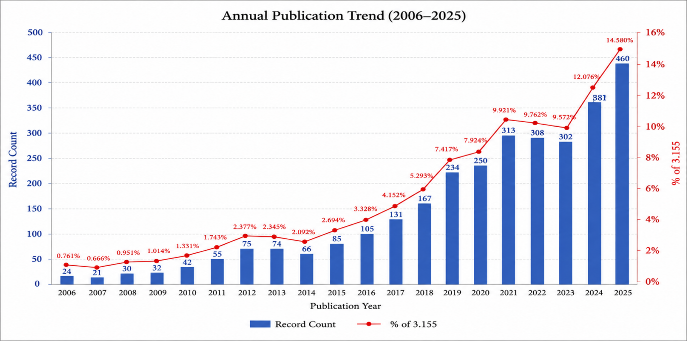
Figure 1. Distribution of studies on intangible cultural heritage studies in gastronomy by year according to the Web of Science database (2006-2025)
Source: Author’s own results

Figure 1 presents the annual publication trend of studies focusing on intangible cultural heritage in gastronomy between 2006 and 2025. The findings demonstrate a continuous and accelerating increase in scientific production throughout the study period. While only 24 publications were indexed in 2006, the annual output reached 460 publications in 2025, representing nearly a twenty-fold increase. This pattern indicates that research on gastronomic intangible cultural heritage has evolved from a relatively niche topic into an established and rapidly expanding interdisciplinary research field.
The substantial increase observed after 2017 may be interpreted as the result of several interconnected developments. First, the growing international recognition of intangible cultural heritage following the implementation of UNESCO's 2003 Convention has encouraged governments, universities, and cultural organizations to invest more actively in heritage-related research. During the last decade, gastronomic heritage has increasingly been recognized not merely as a cultural asset requiring preservation but also as a strategic resource capable of supporting sustainable tourism, regional development, and local identity construction. This conceptual expansion has broadened the scope of academic inquiry and attracted researchers from multiple disciplines, including tourism, anthropology, sociology, environmental sciences, cultural studies, and food science.
The remarkable publication growth observed after 2020 can also be associated with the broader academic emphasis on sustainability and resilient local food systems following the COVID-19 pandemic. The pandemic highlighted the vulnerability of global food supply chains while simultaneously increasing scholarly interest in community resilience, traditional food knowledge, and locally embedded food production systems (Gössling et al., 2021). Consequently, gastronomic heritage became increasingly investigated as a mechanism for strengthening local economies, preserving cultural identity, and promoting sustainable development. Similar publication growth has been reported in recent bibliometric studies examining tourism, cultural heritage, and sustainability research, suggesting that the present findings reflect broader transformations occurring across multiple social science disciplines.
The exceptionally high publication output recorded in 2025 should therefore not be interpreted simply as a numerical increase. Rather, it reflects the growing institutionalization of gastronomic heritage research, the expansion of international collaboration networks, increasing research funding directed toward sustainability and cultural heritage, and the integration of gastronomic heritage into global policy agendas such as the United Nations Sustainable Development Goals. Collectively, these developments demonstrate that intangible cultural heritage in gastronomy has become a mature research domain with increasing theoretical sophistication and international visibility.
Table 2. Top 25 research areas of articles intangible cultural heritage in gastronomy according to the web of science database (2006-2025)
Web of Science Categories | Record Count | % of 3.155
Food Science Technology | 720 | 22.821%
Hospitality Leisure Sport Tourism | 590 | 18.700%
Environmental Sciences | 159 | 5.040%
Environmental Studies | 143 | 4.532%
Nutrition Dietetics | 142 | 4.501%
Green Sustainable Science Technology | 138 | 4.374%
Humanities Multidisciplinary | 131 | 4.152%
Management | 121 | 3.835%
History | 98 | 3.106%
Social Sciences Interdisciplinary | 97 | 3.074%
Sociology | 93 | 2.948%
Agricultural Economics Policy | 89 | 2.821%
Plant Sciences | 86 | 2.726%
Geography | 72 | 2.282%
Business | 71 | 2.250%
Agriculture Multidisciplinary | 56 | 1.775%
Multidisciplinary Sciences | 53 | 1.680%
Economics | 52 | 1.648%
Anthropology | 51 | 1.616%
Agronomy | 50 | 1.585%
Source: Author’s own results
Table 2 demonstrates that research on intangible cultural heritage in gastronomy is distributed across a wide range of Web of Science categories, confirming the highly interdisciplinary nature of the field. Food Science and Technology represents the largest research area (22.82%), followed by Hospitality, Leisure, Sport and Tourism (18.70%). Environmental Sciences, Environmental Studies, Nutrition and Dietetics, and Green and Sustainable Science also occupy prominent positions, indicating that gastronomic heritage research increasingly intersects with sustainability, environmental management, and public health perspectives.
The dominance of Food Science and Technology can be explained by the dual nature of gastronomic heritage itself. Traditional foods represent not only cultural expressions but also physical products whose quality, authenticity, nutritional value, production techniques, and safety require scientific investigation. Consequently, researchers increasingly combine cultural heritage perspectives with food chemistry, food preservation, sensory analysis, and traditional production technologies. This convergence reflects a growing recognition that safeguarding intangible culinary heritage also requires protecting the technical knowledge embedded within traditional food production systems.
The strong representation of Hospitality, Leisure, Sport and Tourism further demonstrates the transformation of gastronomy into a strategic tourism resource. During the past two decades, destinations have increasingly incorporated local culinary traditions into destination branding, experiential tourism, and regional development strategies. As a result, gastronomic heritage has become an important mechanism for enhancing destination competitiveness, creating authentic visitor experiences, and supporting local economic development. Previous studies have similarly emphasized that culinary heritage contributes not only to tourist satisfaction but also to community identity, rural regeneration, and sustainable tourism development.
Another remarkable finding is the increasing presence of Environmental Sciences, Green and Sustainable Science, and Environmental Studies among the leading research categories. This trend reflects the growing influence of sustainability discourse on heritage research. Rather than considering gastronomic heritage exclusively from a cultural preservation perspective, recent studies increasingly investigate its contribution to biodiversity conservation, sustainable agriculture, circular food systems, climate resilience, and responsible consumption. The integration of environmental perspectives indicates that intangible cultural heritage is gradually being repositioned within broader sustainability frameworks, particularly those associated with the United Nations Sustainable Development Goals (SDGs).
The appearance of disciplines such as Sociology, Anthropology, Geography, Agricultural Economics, Business, and Management further illustrates the conceptual expansion of the field. These disciplines investigate gastronomic heritage from different analytical perspectives, including identity construction, social memory, cultural transmission, local governance, consumer behavior, entrepreneurship, and regional competitiveness. Consequently, gastronomic heritage has evolved into a multidimensional research domain that integrates cultural, economic, environmental, political, and social dimensions rather than remaining confined to food-related studies alone.
Overall, the disciplinary diversity identified in Table 2 demonstrates the intellectual maturation of gastronomic heritage research. The coexistence of natural sciences, social sciences, and humanities confirms that the field increasingly requires interdisciplinary collaboration to understand the complex relationships among food, culture, sustainability, tourism, and community development. This multidisciplinary structure is likely to become even more pronounced as future research increasingly addresses global challenges related to sustainable food systems, cultural resilience, and local development.
Table 3. The 20 core journals publishing research intangible cultural heritage in gastronomy according to the web of science database (2006-2025)
Journals | Record Count | % of 3.155
International Journal of Gastronomy and Food Science | 316 | 10.016%
Sustainability | 112 | 3.550%
Journal Of Culinary Science Technology | 64 | 2.029%
Rosa Dos Ventos Turismo E Hospitalidade | 59 | 1.870%
Foods | 57 | 1.807%
Pasos Revista De Turismo Y Patrimonio Cultural | 43 | 1.363%
Food Culture Society | 42 | 1.331%
British Food Journal | 38 | 1.204%
Nutricion Hospitalaria | 33 | 1.046%
Rivar Revista Iberoamericana De Viticultura Agroindustria Y Ruralidad | 25 | 0.792%
Journal Of Heritage Tourism | 24 | 0.761%
Revista Universidad Y Sociedad | 24 | 0.761%
In Situ Revue De Patrimoines | 23 | 0.729%
International Journal of Contemporary Hospitality Management | 20 | 0.634%
International Journal of Hospitality Management | 20 | 0.634%
Journal Of Ethnobiology and Ethnomedicine | 20 | 0.634%
Tourism Recreation Research | 20 | 0.634%
Scientific Papers Series Management Economic Engineering in Agriculture and Rural Development | 19 | 0.602%
Ekonomika Poljoprivreda Economics of Agriculture | 18 | 0.571%
Nutrients | 17 | 0.539%

Table 3 identifies the leading journals publishing research on intangible cultural heritage in gastronomy. The International Journal of Gastronomy and Food Science is the most productive source, followed by Sustainability, Journal of Culinary Science & Technology, Rosa Dos Ventos Turismo e Hospitalidade, and Foods. The concentration of publications within these journals suggests that the field has developed a specialized publication structure supported by journals focusing on gastronomy, tourism, food science, and sustainability.
The dominance of the International Journal of Gastronomy and Food Science reflects its broad interdisciplinary scope, covering cultural heritage, gastronomy, tourism, and food-related research. Similarly, the strong presence of Sustainability indicates the increasing integration of sustainable development perspectives into gastronomic heritage studies. The inclusion of journals dedicated to hospitality, food culture, nutrition, and heritage tourism further demonstrates that the field extends beyond culinary studies and increasingly draws on multiple disciplines. Overall, the distribution of publications across these journals confirms that research on gastronomic heritage has become an established interdisciplinary research area with well-defined publication outlets.
Table 4. Top 20 authors conducting research intangible cultural heritage in gastronomy according to the web of science database (2006-2025)
Researcher Profiles | Record Count | % of 3.155
Fusté-Forné, Francesc | 42 | 1.331%
Lopez-Guzman, Tomas | 25 | 0.792%
Pieroni, Andrea | 21 | 0.666%
Spence, Charles | 17 | 0.539%
Sõukand, Renata | 17 | 0.539%
Alonso, Abel Duarte | 17 | 0.539%
This, Herve | 16 | 0.507%
Zocchi, Dauro Mattia | 14 | 0.444%
Sulaiman, Naji | 13 | 0.412%
Carvache-Franco, Wilmer | 13 | 0.412%
Rojas, Ricardo David Hernández | 12 | 0.380%
Guiné, Raquel P F | 12 | 0.380%
Medina, F. Xavier | 12 | 0.380%
Tesanovic, Dragan | 11 | 0.349%
Carvache-Franco, Mauricio | 11 | 0.349%
Smugovic, Stefan | 10 | 0.317%
Tondo, Eduardo Cesar | 10 | 0.317%
This vo Kientza, Herve Jacques Marie | 10 | 0.317%
Abdul Aziz, Muhammad | 10 | 0.317%
Sousa, Paulo Henrique Machado | 10 | 0.317%
Source: Author’s own results
Table 4 presents the most productive authors in the field, highlighting the emergence of several influential scholars who have shaped the intellectual development of gastronomic heritage research. Francesc Fuste-Forne, the most productive author, has significantly contributed to the literature by examining gastronomic tourism, destination branding, and the role of local food in creating authentic visitor experiences. His studies have strengthened the connection between culinary heritage and sustainable tourism.
Andrea Pieroni has played a key role in integrating ethnobiology and traditional food knowledge into gastronomic heritage research. His work on local ecological knowledge, traditional diets, and biocultural diversity has expanded the theoretical foundations of the field beyond tourism and hospitality, emphasizing the importance of preserving community-based knowledge systems. Likewise, Tomas Lopez-Guzman has contributed extensively to understanding gastronomy as a driver of tourism development, particularly through research on visitor motivations, destination competitiveness, and regional economic development.
The prominence of these scholars indicates that the field has evolved through complementary research perspectives combining cultural heritage, tourism, sustainability, and traditional knowledge. Rather than developing within a single discipline, gastronomic heritage research has progressed through interdisciplinary contributions that continue to shape its theoretical and practical directions.
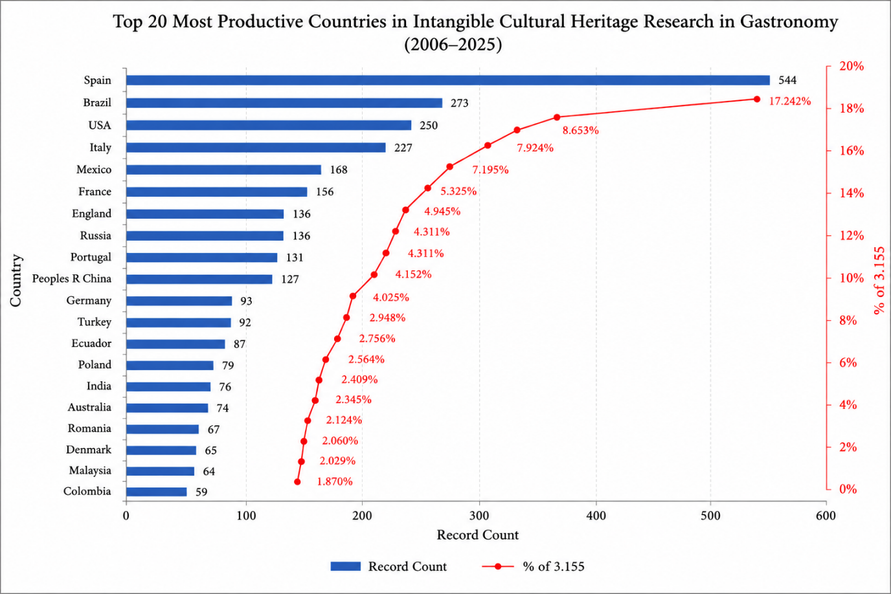
Figure 2. Top 20 countries conducting the most research intangible cultural heritage in gastronomy according to the web of science database (2006-2025)
Source: Author’s own results
Figure 2 shows that Spain is the leading contributor to research on intangible cultural heritage in gastronomy, followed by Brazil, the United States, Italy, and Mexico. The predominance of European countries suggests that research in this field has been strongly influenced by regions where cultural heritage policies and gastronomy have long been integrated into tourism and regional development strategies.
Spain's leading position may be associated with its internationally recognized gastronomic heritage, strong tradition of food and tourism research, and active engagement in cultural heritage initiatives, which have made the country one of the leading contributors to gastronomic heritage scholarship (Bessière, 1998). Although Brazil ranks second, its publication output is approximately half that of Spain. This difference may reflect variations in research priorities and publication patterns rather than research capacity alone. Brazilian research has traditionally focused on biodiversity, food security, and agricultural systems, while Spanish scholars have more frequently examined gastronomy from cultural heritage and tourism perspectives. Despite this difference, Brazil's strong position demonstrates the growing contribution of emerging economies to the international literature. Overall, the geographical distribution indicates that while Europe remains the intellectual center of gastronomic heritage research, increasing contributions from Latin America and Asia suggest that the field is becoming more internationally diverse. This trend is likely to encourage broader comparative research and strengthen international collaboration in the coming years.
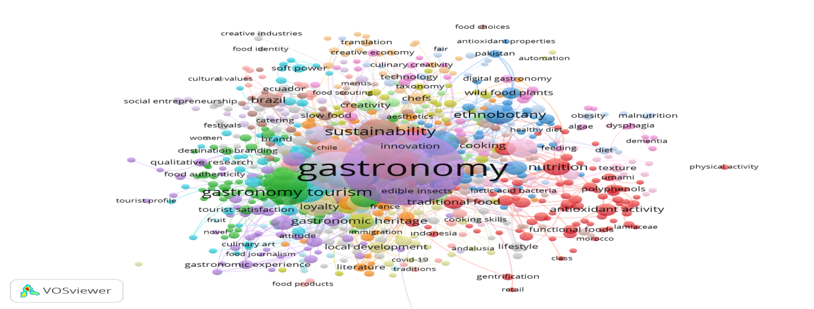
Figure 3. Output of keyword co-occurrence map of intangible cultural heritage in gastronomy studies
Source: Author’s own results

Figure 3 illustrates the conceptual structure of research on intangible cultural heritage in gastronomy through keyword co-occurrence analysis. The network is organized into several interconnected thematic clusters, reflecting the evolution of the field from heritage preservation to broader sustainability and tourism perspectives. The largest cluster is centered on gastronomy, cultural heritage, authenticity, and traditional knowledge. This cluster represents the theoretical foundation of the literature and is closely associated with studies emphasizing the preservation of culinary traditions, cultural identity, and the transmission of local knowledge across generations (Bessière, 1998; Kirshenblatt-Gimblett, 1998; Cohen & Avieli, 2004).
A second major cluster focuses on sustainability, tourism, and local development. The close association between these keywords suggests that recent studies increasingly examine gastronomic heritage as a strategic resource for sustainable tourism, destination branding, and rural development. Rather than viewing traditional cuisine solely as a cultural asset, contemporary research highlights its contribution to local economies, community resilience, and sustainable development, reflecting the growing influence of sustainability-oriented research.
The strong links between the thematic clusters indicate that these research areas are closely connected rather than independent. Heritage preservation provides the cultural foundation of the field, while sustainability and tourism research expand its practical and socio-economic dimensions. This interconnected structure demonstrates that gastronomic heritage has evolved into an interdisciplinary research area that integrates cultural studies, tourism, food science, and sustainability, highlighting its increasing relevance for both academic research and policy development.
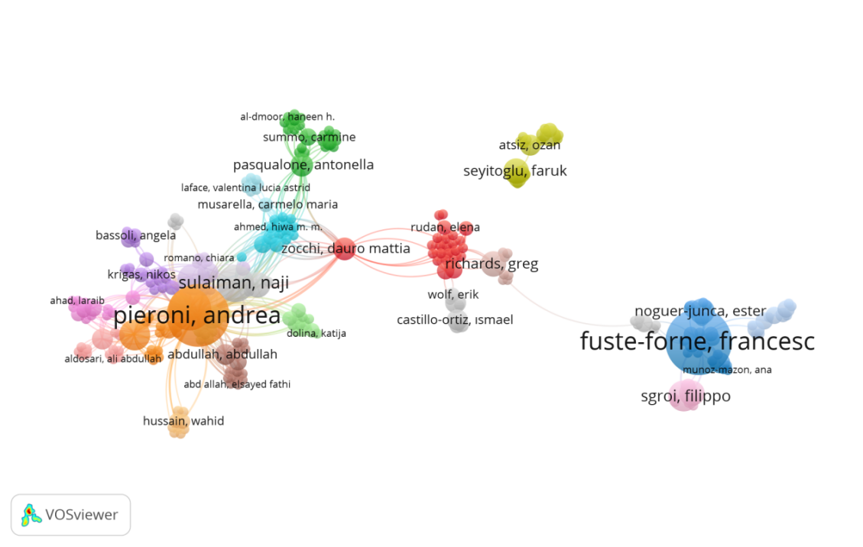
Figure 4. Map of co-authorship networks intangible cultural heritage in gastronomy (2006-2025)
Source: Author’s own results
Figure 4 presents the co-authorship network of researchers working on intangible cultural heritage in gastronomy. The network reveals several well-connected research groups linked by a limited number of highly influential authors, indicating that scientific collaboration is concentrated around a small number of established scholars. In particular, authors such as Francesc Fusté-Forné and Andrea Pieroni occupy central positions, reflecting their important role in connecting different research communities and facilitating knowledge exchange across disciplines.
The collaboration pattern also highlights the interdisciplinary nature of the field. Researchers from tourism, food studies, cultural heritage, anthropology, and sustainability frequently collaborate, contributing to the integration of diverse theoretical and methodological perspectives. At the same time, the presence of several smaller and less connected groups suggests that opportunities remain to strengthen international and interdisciplinary collaboration. Expanding cooperation between established and emerging research teams may enhance knowledge exchange and support the continued development of the field.
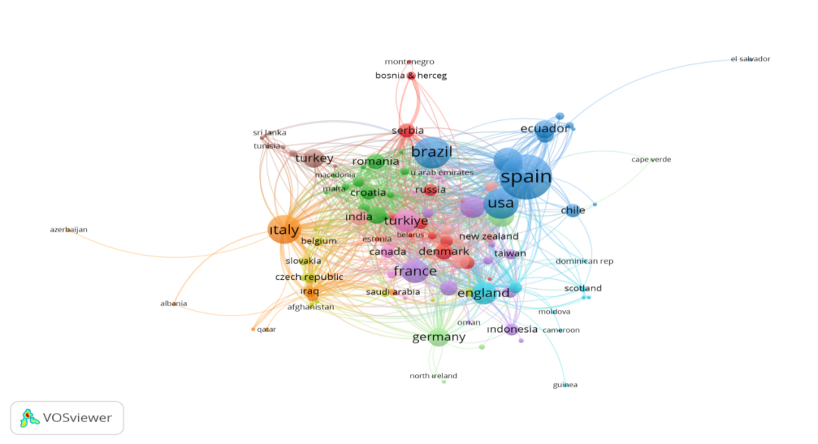
Figure 5. Map of country co-authorship networks intangible cultural heritage in gastronomy (2006-2025)
Source: Author’s own results
Figure 5 illustrates the international co-authorship network in research on intangible cultural heritage in gastronomy. Spain, Brazil, the United States, Italy, and France occupy central positions within the network, indicating their leading role in both scientific productivity and international collaboration. Their strong collaborative links suggest that these countries function as major hubs for knowledge exchange, facilitating the dissemination of ideas and the development of interdisciplinary research.
The predominance of European countries reflects the long-standing integration of cultural heritage into tourism, regional development, and sustainability policies, which has encouraged cross-border academic collaboration. In contrast, the growing participation of countries such as Türkiye, Romania, India, and Ecuador indicates that the field is becoming increasingly international. These emerging collaborations suggest that research on gastronomic heritage is expanding beyond its traditional European focus, allowing new cultural contexts and perspectives to contribute to the literature. Overall, the network demonstrates that international collaboration has become an important driver of knowledge production and is likely to play a key role in the future development of this interdisciplinary research field.
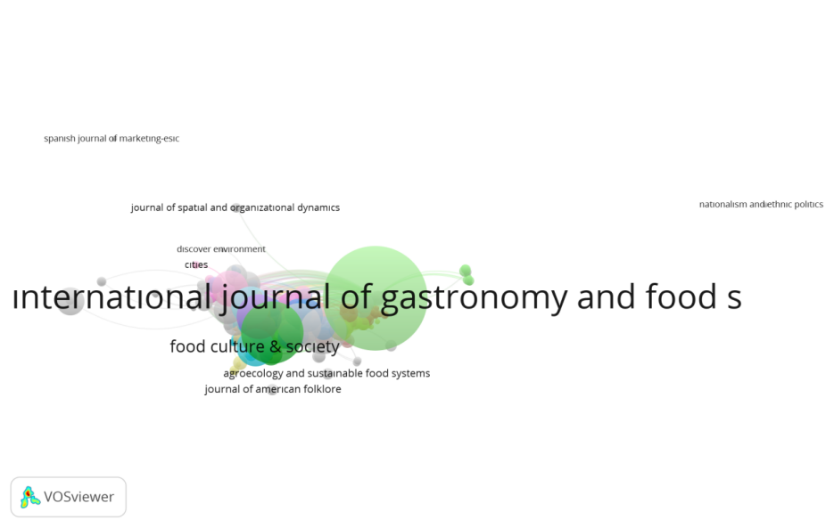
Figure 6. Map of journals citations networks intangible cultural heritage in gastronomy
Source: Author’s own results
Figure 6 presents the journal citation network in research on intangible cultural heritage in gastronomy. The International Journal of Gastronomy and Food Science occupies the most influential position within the network, reflecting its central role in shaping the intellectual development of the field. Its strong citation links with journals focusing on tourism, food culture, sustainability, and hospitality indicate that research on gastronomic heritage is supported by diverse disciplinary perspectives.
The citation network demonstrates that knowledge production in this field is no longer confined to gastronomy alone. Instead, it increasingly incorporates concepts from cultural studies, environmental sciences, tourism, and sustainable development. This interdisciplinary citation pattern suggests that researchers draw upon complementary theoretical and methodological approaches to better understand the cultural, economic, and social dimensions of gastronomic heritage. These findings indicate that, the network highlights the growing maturity of the field, where specialized gastronomy journals provide the core knowledge base while sustained interactions with related disciplines contribute to expanding its theoretical scope and practical relevance.
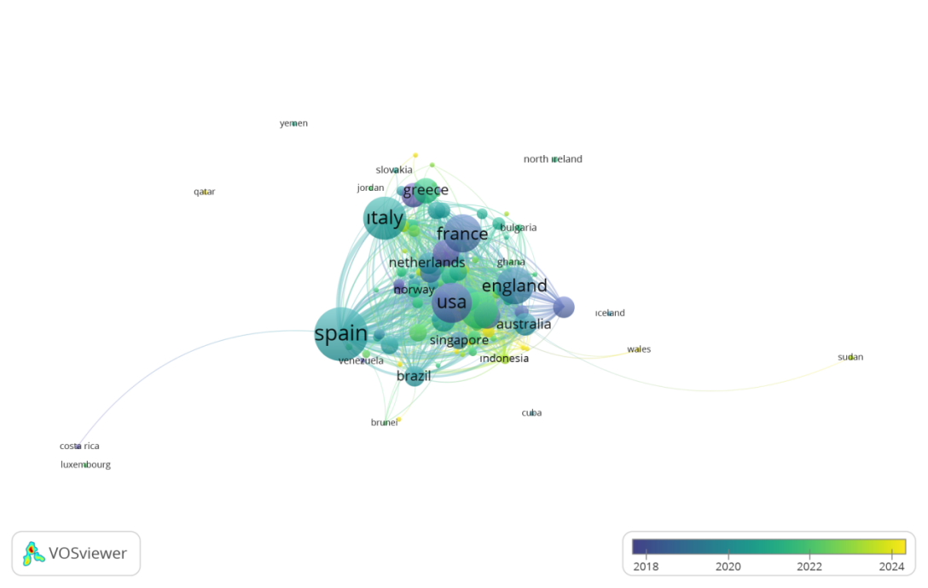
Figure 7. Map of countries citations networks intangible cultural heritage in gastronomy
Source: Author’s own results
Figure 7 presents the country citation network in research on intangible cultural heritage in gastronomy. Spain, Italy, France, the United States, and England occupy the most influential positions, indicating that these countries have made substantial intellectual contributions to the development of the field. Their high citation impact suggests that research produced in these countries serves as a key reference for subsequent studies and has significantly shaped the theoretical and methodological direction of the literature.
The overlay visualization also reveals a temporal shift in research activity. Earlier influential studies were primarily concentrated in established research countries, whereas more recent contributions increasingly originate from Brazil, Indonesia, Singapore, and other emerging research communities. This trend reflects the gradual internationalization of gastronomic heritage research and the growing participation of countries with diverse cultural and gastronomic traditions. These findings indicate that, although European countries continue to play a leading role in terms of scientific influence, the field is becoming increasingly geographically diverse. The expanding citation impact of emerging countries is likely to enrich future research by introducing new perspectives, cultural contexts, and comparative approaches to the study of gastronomic heritage.
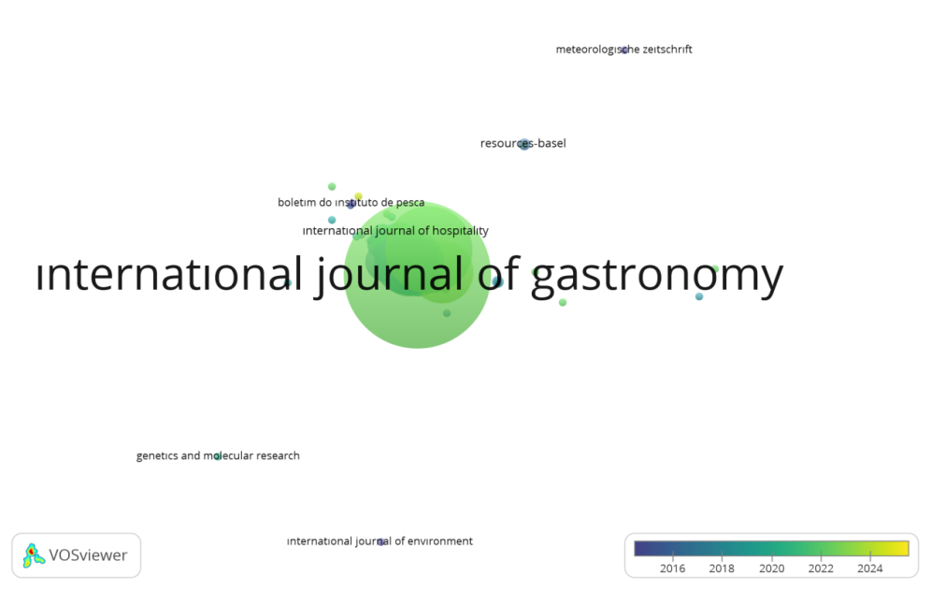
Figure 8. Map of journals bibliographic couples networks intangible cultural heritage in gastronomy
Source: Author’s own results
Figure 8 presents the bibliographic coupling network of journals publishing research on intangible cultural heritage in gastronomy. The International Journal of Gastronomy and Food Science occupies the central position in the network, indicating that it shares a common intellectual foundation with many of the leading journals in the field. This finding suggests that research published in these journals is built upon similar theoretical frameworks and frequently draws on the same body of literature.
Strong coupling relationships among journals specializing in gastronomy, hospitality, tourism, and sustainability demonstrate the convergence of these disciplines in the study of gastronomic heritage. Rather than developing independently, researchers increasingly combine concepts from cultural heritage, food studies, tourism, and sustainable development to address complex research questions. This pattern reflects the growing integration of interdisciplinary knowledge within the field.
These findings suggest that gastronomic heritage research has established a relatively coherent intellectual structure supported by a shared knowledge base. At the same time, the inclusion of journals from different disciplines indicates that the field continues to evolve by incorporating new theoretical perspectives and expanding its research scope.
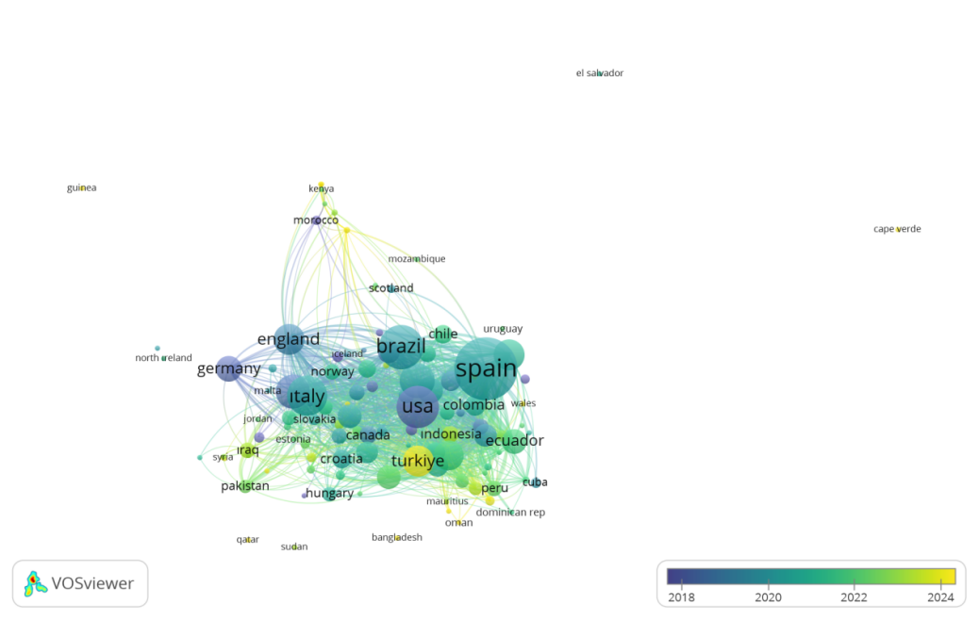
Figure 9. Map of countries bibliographic couples networks intangible cultural heritage in gastronomy
Source: Author’s own results
Figure 9 illustrates the bibliographic coupling network of countries in research on intangible cultural heritage in gastronomy. Spain, the United States, Italy, Brazil, England, and Germany occupy the most central positions, indicating that researchers from these countries rely on similar theoretical frameworks and frequently build upon the same body of literature. This shared intellectual foundation reflects the strong integration of leading research communities within the field.
The overlay visualization further shows that countries such as Türkiye, Indonesia, Ecuador, and Peru have become more visible in recent years, suggesting a gradual diversification of the global research landscape. Although these countries remain less integrated than the established research hubs, their increasing participation introduces new cultural contexts and research perspectives that enrich the existing literature.
These findings demonstrate that gastronomic heritage research is supported by a well-established international knowledge base while continuing to expand geographically. As more countries contribute to the literature, greater intellectual diversity and cross cultural comparisons are expected to strengthen the future development of the field.
4. Limitations and Future Research
Despite its contributions, this study has several methodological limitations that should be acknowledged. First, the analysis was restricted to publications indexed in the Web of Science Core Collection. Although Web of Science is widely regarded as one of the most reliable databases for bibliometric research, the exclusion of publications indexed in databases such as Scopus, Dimensions, Google Scholar, and regional indexing systems may have limited the comprehensiveness of the knowledge map, particularly with respect to research produced in underrepresented geographical regions and non-English academic communities. In addition, the findings are inherently influenced by the selected search strategy, keywords, and inclusion criteria, meaning that studies employing alternative terminology may not have been captured.
Second, bibliometric analysis primarily examines patterns of scientific production, citation, and collaboration rather than assessing the theoretical sophistication, methodological quality, or practical impact of individual studies. Citation-based indicators are also affected by publication age, disciplinary citation practices, and database coverage. Consequently, the findings should be interpreted as reflecting the evolution and structure of the research field rather than providing a direct evaluation of research quality.
Future studies can build upon these limitations by integrating multiple bibliographic databases to obtain a more comprehensive representation of the field and by combining bibliometric techniques with systematic literature reviews, content analysis, or other qualitative evidence-synthesis methods. Such mixed-method approaches would enable a deeper examination of conceptual development, theoretical perspectives, and methodological trends while providing richer explanations of how knowledge in this field has evolved.
Finally, future research should further investigate the emerging themes identified in this study, particularly digital heritage preservation, artificial intelligence, sustainable gastronomy, climate change adaptation, food sovereignty, community resilience, and inclusive heritage governance. Comparative and longitudinal studies conducted across different cultural and geographical contexts would contribute to a better understanding of how gastronomic intangible cultural heritage responds to contemporary social, environmental, and technological transformations. Advancing interdisciplinary and theory-driven research in these areas will be essential for strengthening both the scientific foundations and the practical relevance of this rapidly evolving field.
5. Conclusion
This study mapped the intellectual structure and thematic evolution of intangible cultural heritage research in gastronomy through a comprehensive bibliometric analysis of 3,155 publications indexed in the Web of Science Core Collection between 2006 and 2025. The findings demonstrate that this research field has experienced remarkable growth over the past two decades, evolving into an increasingly interdisciplinary domain characterized by expanding publication output, diversified research themes, and strengthening international collaboration. Sustainability, gastronomic tourism, cultural identity, and heritage preservation emerged as the principal conceptual pillars of the field, while innovation, digitalization, consumer experience, and regional development represent emerging directions that are reshaping its future research agenda.
Beyond mapping publication and citation patterns, this study contributes to the theoretical development of the field by revealing how research on gastronomic intangible cultural heritage has evolved from a predominantly preservation-oriented perspective toward more integrative approaches that connect cultural sustainability, tourism development, destination competitiveness, consumer behavior, and innovation. The temporal evolution of thematic clusters indicates that gastronomic heritage is increasingly understood not only as a cultural resource requiring safeguarding but also as a strategic asset capable of supporting sustainable development, community resilience, creative economies, and place branding. By identifying the major research streams, influential contributors, and collaborative networks, this study provides a comprehensive knowledge framework that can facilitate interdisciplinary dialogue and guide future theoretical development across tourism, hospitality, cultural heritage, anthropology, geography, marketing, and sustainability studies.
The findings also generate important practical and policy implications. The growing emphasis on sustainability and community-oriented heritage management highlights the need for policymakers, cultural institutions, and destination management organizations to integrate intangible gastronomic heritage into broader tourism, cultural, and regional development strategies. Strengthening collaboration among researchers, local communities, public authorities, and tourism stakeholders can enhance both the safeguarding of traditional food knowledge and its contribution to local economic development, destination competitiveness, and authentic visitor experiences. These findings also provide valuable guidance for practitioners seeking to develop sustainable destination branding and community-based tourism initiatives grounded in local gastronomic heritage.
In conclusion, this study establishes a comprehensive evidence base for understanding the evolution of gastronomic intangible cultural heritage research over nearly two decades. By identifying the field's conceptual foundations, emerging research frontiers, and global collaboration patterns, it offers a strategic roadmap for future scholarship while supporting evidence-based policies and management practices aimed at safeguarding gastronomic heritage and promoting sustainable cultural and tourism development in an increasingly interconnected world.

Authorship contribution: To be completed after the review process is finished.
Data Availability Statement: : All data and materials generated or analyzed during this study are included in this published article and its supplementary information. Data will be made available on request.
Compliance with ethical standards: The authors declare that the study was conducted in accordance with ethical standards (and, where applicable, with the approval of the relevant ethics committee / with the informed consent of participants).
Funding: To be completed after the review process is finished.
Acknowledgments: To be completed after the review process is finished.
Conflicts of interest: The authors declare no competing interests.

References
Appadurai, A. (1996). Modernity at large: Cultural dimensions of globalization. University of Minnesota Press.
Aria, M., & Cuccurullo, C. (2017). Bibliometrix: An R-tool for comprehensive science mapping analysis. Journal of Informetrics, 11(4), 959-975. https://doi.org/10.1016/j.joi.2017.08.007
Ashworth, G. J., Graham, B., & Tunbridge, J. E. (2007). Pluralising pasts: Heritage, identity and place in multicultural societies. Pluto Press.
Bendix, R. (2009). Heritage between economy and politics: An Assessment from the perspective of cultural anthropology. In L. Smith, N. Akagawa (Eds.), Intangible heritage (pp. 253-269). Routledge.
Bessière, J. (1998). Local development and heritage: Traditional food and tourism in rural France. Journal of Rural Studies, 14(1), 1-10. https://doi.org/10.1016/S0743-0167(97)00043-3
Bourdieu, P. (1984). Distinction: A social critique of the judgement of taste (R. Nice, Trans.). Harvard University Press.
Bourdieu, P. (1986). The forms of capital. In J. G. Richardson (Ed.), Handbook of theory and research for the sociology of education (pp. 241-258). Greenwood.
Buragohain, D., Meng, Y., Deng, C., Li, Q., & Chaudhary, S. (2024). Digitalizing cultural heritage through metaverse applications: Challenges, opportunities, and strategies. Heritage Science, 12(1), 295. https://doi.org/10.1186/s40494-024-01403-1
Butler, J. (1990). Gender trouble: Feminism and the subversion of identity. Routledge.
Chen, J., Guo, Z., Xu, S., Law, R., Liao, C., He, W., & Zhang, M. (2022). A Bibliometric analysis of research on intangible cultural heritage tourism using CiteSpace: The perspective of China. Land, 11(12), 2298. https://doi.org/10.3390/land11122298
Cohen, E., & Avieli, N. (2004). Food in tourism: Attraction and impediment. Annals of Tourism Research, 31(4), 755-778. https://doi.org/10.1016/j.annals.2004.02.003
Correa, A. R., Robayo, A., Llano, F. A., & Niño Soto, A. (2025). Local amphibious cuisine: Toward the rediscovery of the gastronomic traditions of the palafito town of Buenavista, Cienaga Grande Santa Marta, Colombia. International Journal of Gastronomy and Food Science, 41, 101218. https://doi.org/10.1016/j.ijgfs.2025.101218
Counihan, C., & Van Esterik, P. (Eds.). (2013). Food and culture: A reader (3rd ed.). Routledge.
Donthu, N., Kumar, S., Mukherjee, D., Pandey, N., & Lim, W. M. (2021). How to conduct a bibliometric analysis: An overview and guidelines. Journal of Business Research, 133, 285-296. https://doi.org/10.1016/j.jbusres.2021.04.070
Duman, H., & Avcıkurt, C. (2023). Evaluation of local dishes as an intangible cultural heritage value in terms of gastronomy tourism: The case of Ayvalık. Journal of Gastronomy, Hospitality and Travel, 6(2), 548-557. https://doi.org/10.33083/joghat.2023.283
Featherstone, M. (1995). Undoing culture: Globalization, postmodernism and identity. Sage.
Fischler, C. (1988). Food, self and identity. Social Science Information, 27(2), 275-292. https://doi.org/10.1177/053901888027002005
García-Henche, B., Cuesta-Valiño, P., Durán-Álamo, P., & Penelas-Leguía, A. (2024). The role of women in maintaining the heritage value of gastronomy in Castilla-La Mancha. International Journal of Gastronomy and Food Science, 37, 100987. https://doi.org/10.1016/j.ijgfs.2024.100987
Gössling, S., Scott, D., & Hall, C. M. (2021). Pandemics, tourism and global change: a rapid assessment of COVID-19. Journal of Sustainable Tourism, 29(1), 1-20. https://doi.org/10.1080/09669582.2020.1758708
Hafstein, V. T. (2009). Intangible heritage as a list: From masterpieces to representation. In L. Smith, N. Akagawa (Eds.), Intangible heritage (pp. 93-111). Routledge.
Hall, S. (1996). Cultural identity and diaspora. In P. Mongia (Ed.), Contemporary postcolonial theory: A reader (pp. 329-338). Arnold / Oxford University Press.
Hannerz, U. (1996). Transnational connections: Culture, people, places. Routledge.
Harrison, R. (2013). Heritage: Critical approaches. Routledge.
Harvey, D. (2001). Heritage pasts and heritage presents: Temporality, meaning and the scope of heritage studies. International Journal of Heritage Studies, 7(4), 319-338. https://doi.org/10.1080/13581650120105534
He, Z., & Wen, C. (2024). Construction of digital creation development model of intangible cultural heritage crafts in China. Humanities and Social Sciences Communications, 11, 1745. https://doi.org/10.1057/s41599-024-04331-4
Karaman, R. (2026). Edible insects as sustainable food and feed sources: a bibliometric analysis using VOSviewer. Journal of Insects as Food and Feed, 1(aop), 1-19. DOI:10.1163/23524588-bja10370
Kirshenblatt‑Gimblett, B. (1998). Destination culture: Tourism, museums, and heritage. University of California Press.
Kurnaz, A., Akyurt Kurnaz, H., & Aslan, E. (2026). The İmece tradition in the context of gastronomic cultural heritage. International Journal of Gastronomy and Food Science, 43, 101408. https://doi.org/10.1016/j.ijgfs.2026.101408
Li, M., Xu, S., Tang, J., & Chen, W. (2024). Design and research of digital twin platform for handicraft intangible cultural heritage-Yangxin Cloth Paste. Heritage Science, 12, 43. https://doi.org/10.1186/s40494-024-01161-0
Lowenthal, D. (1998). The past is a foreign country (2nd ed.). Cambridge University Press.
Min, W. (2025). A scientometric review of cultural heritage management and sustainable development through evolutionary perspectives. npj Heritage Science, 13, 215. https://doi.org/10.1038/s40494-025-01708-9
Mintz, S. W., & Du Bois, C. M. (2002). The anthropology of food and eating. Annual Review of Anthropology, 31, 99-119. https://doi.org/10.1146/annurev.anthro.32.032702.131011
Ritzer, G. (2011). The McDonaldization of society (6th ed.). Pine Forge Press/Sage Publications Co.
Robertson, R. (1995). Glocalization: Time-space and homogeneity-heterogeneity. In M. Featherstone, S. Lash, & R. Robertson (Eds.), Global modernities (pp. 25-44). Sage.
Silva, F. M., Ramazanova, M., & Freitas, I. V. (2025). Safeguarding traditional Portuguese gastronomy as an intangible cultural heritage through tourism: The case of North of Portugal. Tourism and Hospitality, 6(2), 92. https://doi.org/10.3390/tourhosp6020092
Smith, L. (2006). Uses of heritage. Routledge.
Su, X., Li, X., & Kang, Y. (2019). A bibliometric analysis of research on intangible cultural heritage using CiteSpace. SAGE Open, 9(2), 2158244019840119. https://doi.org/10.1177/2158244019840119
Throsby, D. (2010). The economics of cultural policy. Cambridge University Press.
Timothy, D. J., & Boyd, S. W. (2003). Heritage tourism. Prentice Hall.
Türker, A. (2026). A bibliometric analysis of research on intangible cultural heritage in the field of tourism. Social Sciences & Humanities Open, 13, 102405. https://doi.org/10.1016/j.ssaho.2025.102405
UNESCO. (2003). Convention for the safeguarding of the intangible cultural heritage. https://ich.unesco.org/en/convention
Zhao, L., & Kim, E. (2025). Urban revitalization of world heritage cities through cultural and creative industries: A case study of Pingyao under the cities, culture, and creativity framework. Sustainability, 17(10), 4292. https://doi.org/10.3390/su17104292
Zupic, I., & Čater, T. (2015). Bibliometric methods in management and organization. Organizational Research Methods, 18(3), 429-472. https://doi.org/10.1177/1094428114562629

Disclaimer/Publisher’s Note: The statements, opinions and data contained in all publications are solely those of the individual author(s) and contributor(s) and not of Publisher and/or the editor(s). Publisher and/or the editor(s) disclaim responsibility for any injury to people or property resulting from any ideas, methods, instructions or products referred to in the content.

